Myrtle Beach Art Colony Workshops
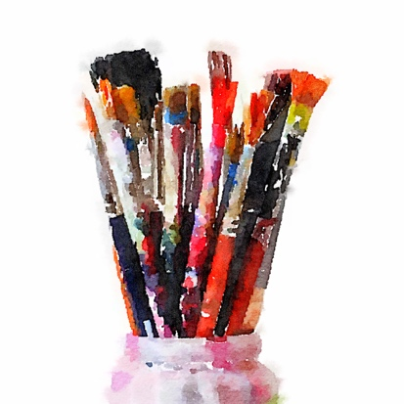
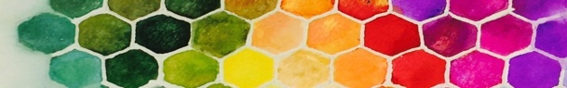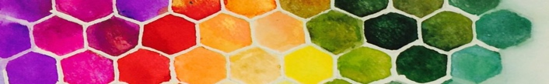

Art Myrtle Beach, and Rebecca Zdybel are happy to announce 3 separate opportunities for creatives to come together as artists and paint together with the goal of creating our own unique art colony for the week.

When:
- Fall 2018 Session- 11/04/2018- 11/09/2018
- Spring 2019 Session- 3/24/19 -3/29/19
- Fall 2019 Session- 11/10/2019 - 11/15/2019

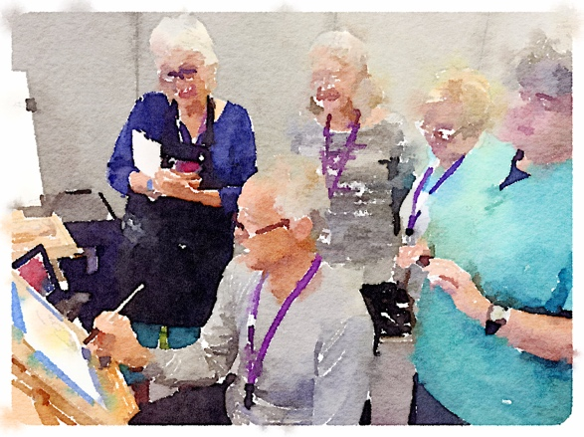
Background: This event is born of many years of wonderful experiences at Springmaid Watermedia Workshops in Myrtle Beach. For anyone who has attended in these workshops in the past, you know the power of artists coming together in community to work and share. Historically these workshops have been all inclusive and very expensive. To try and create a lower cost alternative, I have made this arrangement. ❤

Overview: Set up will be on on Sunday with an optional meet and greet social in the evening at a local restaurant. Monday through Friday Independent studio time in our spacious ocean view studio.

Details- This is an opportunity for fellow creatives to gather and share a concentrated week of painting. We will check out of our regular lives and check into our oceanfront studio! The location is one where you can spread out, and paint your heart out for the week!

There will be no "instructor" other than the inspiration we gain from one another. Once we set up, there will be no need to clean up...the studio is ours for the week. I plan to organize some “happy hour presentations” made by those in our group who may be interested in sharing a technique or an idea. Interested participants can attend if they wish.

Cost: $300. Registration can be made by sending a check.
Make your check payable to Art Myrtle Beach LLC, 238 Center Dr., Myrtle Beach, SC, 29572
(Note- this will reserve your place in the workshop, with an individual 6-8 ft table.
- No food or drink will be included in this price.
- Lodging rates are separate.
- Special groups rates for rooms at the resort are available and described below.
- Payments for workshop are non-refundable but transferable to another painter if you cannot attend. It is the participant’s responsibility to find a substitute.)

Vision: My hope is to create the setting and let the participating Artists create the experience...sharing, painting, and learning from one another in a weeklong independent art community where all water-based media will be welcomed. I plan to set up optional daily sharing demos for those interested in giving them, and for those who are curious about what others might be doing. Fall 2018 Session will be preceded by Janet Rogers and Don Andrews in 2019. If you'd like to come the week before to enjoy the instruction, you could think about staying for this second week. It could be used a time to independently practice what you may have learned during the week before.

Location of Workshop:
- Long Bay Oceanfront Resort, 7200 N Ocean Blvd, Myrtle Beach, SC 29572
- See location on Google maps
- Note- *Lodging is not included in the $300 cost of the workshop. Participants are responsible for their own lodging arrangements, rates in the tables below.

Myrtle Beach, SC is famous for its family friendly orientation and its gorgeous beaches. Golf, Live Entertainment and Great restaurants abound. Long Bay Oceanfront Resort is located very close to some of the best new restaurants in Myrtle Beach. There is also a nice restaurant on site- “Marlins”. Locals are known to go there for its good food. Starbucks is also onsite.

The oceanfront ballroom which will serve as our studio connects directly to the 3rd floor of a covered parking garage. This makes loading and unloading very convenient. The spacious ballroom has great lighting and an ocean view.

Onsite lodging information: Room reservations will be made independently by participants. Reservations can be made in advance at these rates. Note- reference this workshop when making reservations.

Fall 2018 Art Colony Room Rates | 11/4/18-11/9/18
ROOM TYPE | RATE
Oceanfront Standard Double | $59
Oceanfront 1-Bedroom Suite | $79
Oceanfront 3-Bedroom Condo | $119

Spring 2019 Art  Colony Room Rates | 3/24/19- 3/29/19
ROOM TYPE | RATE
Oceanfront Standard Double | $69
Oceanfront 1-Bedroom Suite | $89
Oceanfront 3-Bedroom Condo | $129

Fall 2019 Art  Colony Room Rates | 11/10/19- 11/15/19
ROOM TYPE | RATE
Oceanfront Standard Double | $69
Oceanfront 1-Bedroom Suite | $89
Oceanfront 3-Bedroom Condo | $129

Group discounted rates valid 3 days prior and 3 days past the above listed dates.
Hotel room rates are subject to applicable Taxes (currently 13%) and $11.30 Resort Fee.
Check-in time: 3:00pm, Check-out time: 11:00am.

Please call 855-842-8318 to make reservations and reference your Group name when speaking with the reservationist.

Transportation: If you’d like to drive around, shop, and see Myrtle Beach, a car rental is advised. If you want to take an Uber or cab from the airport, you could come and stay the week at Long Bay without a car. The restaurants onsite and within walking distance would make doing without a car possible.

Let me know if you have any other questions I can help you with.
Love and light,
Rebecca Zdybel

