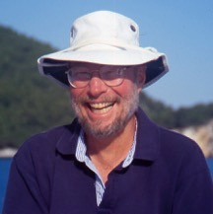
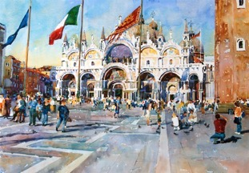Watercolor Workshop With Steve Rogers NWS, AWS, TWSA

Steve Rogers NWS, AWS, TWSA
Rebecca Zdybel and ArtMyrtleBeach.com host this Award Winning national and international watercolor artist/instructor for a fantastic Ocean Front Watercolor Week!

Steve’s paintings have won hundreds of awards in juried competitions including the National Watercolor Society Purchase Award -“Best of Show” in 2006 and four awards in the American Watercolor Society. Steve is a Signature Member of the American Watercolor Society and was an Ambassador/Director of AWS and is also a Signature Member of the National Watercolor Society and Transparent Watercolor Society of America. He was the National Invited Juror for the 2007 AWS Exhibition where he served on the Jury of Selection. He was the Chairman of the Jury of Awards for the 2010 AWS Exhibition and he was the 2014 Juror and sole Awards Judge for TWSA. Steve’s work has been featured in the magazines Watercolor Magazine, Watercolor Magic, International Artist, l'Art de l'Aquaelle, Pratique des Arts and the books Expressing the Visual Language of the Landscape, Secrets from the Contemporary Watercolor Masters - vol. 1 (in Chinese), The One Hour Watercolorist, and a Gallery of Marine Art, as well as two best - selling DVD’s – 7 Secrets of Painting Reflections in Watercolor and The Secrets of Painting Light and Shadow in Watercolor.
Check out his websitewww.watercolorsbyrogers.com

Workshop: Painting Light and Color in Watercolor
“In this workshop I will give students the tools to create painterly and believable watercolors; but more importantly, I seek to take them beyond merely “copying” their subject. An artist needs to also paint from his heart and seek to communicate the emotional and spiritual beauty of God’s creation.” I paint and teach in a very straightforward traditional manner because I believe I can most honestly say what I want to with my brush and juicy watercolor paint. Workshop participants will learn about light and color and the way watercolor behaves, dealing with dark values in watercolor, painting reflections and much, much more. The goal of my workshop is to encourage each artist to advance his or her own vision and to improve the skills necessary to communicate that in watercolor. I have enjoyed teaching watercolor for over 30 years and both my students and I have a lot of fun during the workshop. Steve paints mini demos and full paintings and there is plenty of student painting time and personal help available every day.

N. Myrtle Beach, SC Workshop dates: 11-14 thru 11/18, 2016
(Set up Sunday 11/13 from 3-4:30 PM Intro at 4:30) Classes 9A-4PM Mon-Friday)

Location: Beach Cove Oceanfront Resort
Address: 4800 S Ocean Blvd,
NORTH Myrtle Beach, SC 29582
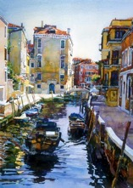
Our classroom is very large and well lit, with large individual tables for each participant. The oceanfront setting will inspire and soothe, and allow for refreshing walks on the beach. Bring snacks or lunch. Classes are from 9A-4P with a break for lunch. All students will have access to the classroom at 8AM and after hours in the evenings till 11PM if desired. One evening group dinner is included.

How to register
A minimum deposit of $100 is due with your registration form and required to reserve your seat. Make checks payable to Rebecca Zdybel and send payment to 238 Center Drive, Myrtle Beach, SC 29572
- Full payment is due 9/15/2016
- Cancellation policy: A full refund minus $50 administrative fee will be given if instructor must cancel for any reason, or if you cancel prior to 9/15/16 and your spot can be filled. After that date, refunds are not guaranteed, but I will make an effort to fill your seat from the waiting list. We are not responsible for travel expenses. Travel insurance is recommended.
- Material lists will be provided upon full payment
.

Hotel accommodations are not included. Beach Cove resort is close to restaurants, shopping, and theaters. Address: 4800 S Ocean Blvd, NORTH Myrtle Beach, SC 29582

For Beach Cove Resort reservations call 800-222-2141 press
option 1 (note that you are attending the Steve Roger’s October 2016 Workshop) Call for more current room rate information
Oceanfront Executive Suite: $58+ taxes/fees= $77.70/night
2 BR Oceanfront Condo: $99+ taxes/fees= $123.31/night
3 BR Oceanfront Condo: $129+taxes/fees= $156.51/night

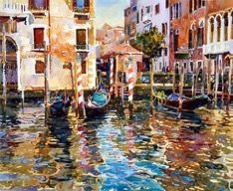
Fees: The total fee is $550. A deposit of $100 is due upon registration and is required to reserve your place at the workshop. Make checks payable to Rebecca Zdybel. The remaining $450 is due by Sept. 15, 2016. Our workshops fill almost immediately so early registration is encouraged. Enrollment will be limited.
Please mail or email the registration information below to:
Rebecca Zdybel- Artmyrtlebeach.com Workshop
238 Center Dr., Myrtle Beach, SC 29572 or Email information to:
rebecca@artmyrtlebeach.com Text or call cell phone 843-450-2307

Steve Roger’s Artmyrtlebeach.com Workshop
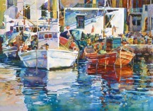
Your Name:
Address:

Email address:
Cell Phone #:
Home Phone #:
Amount Enclosed:
Will you be staying at Beach Cove resort? Yes/No

